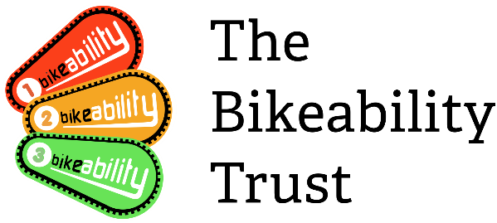

Widening Participation Fund Application Form
Please complete the form answering all questions. Please refer to the Widening Participation Fund Guidance for more information. If you have any questions about completing this application form please contact the Bikeability team at innovationfund@bikeabilitytrust.org
Please send completed forms and additional information to innovationfund@bikeabilitytrust.org by 5pm on 29th October 2021
You will receive an email to confirm your application has been received by the Bikeability team. Successful applicants will be notified by 10th December 2021.

Part 1: Contact details
Please enter your name, address, email, phone and lead contact name.
Organisation Name
Address
Post code
Contact name
Email address
Telephone number
Additional contact details

Part 2: Project Background
Please answer the following questions in order giving as much information as you can;
- Which children do you feel currently miss out being able to access Bikeability Training?
- What do you see as being the biggest issue regarding this in your area?
- Why do you think this is?
- What are the barriers?
- What anecdotal or hard evidence can you provide to back this up?

Part 3: Solutions
Please answer the following;

- How do you think you can address these problems and overcome the barriers you have identified in part 2 above?
- Please provide a clear plan with timescales and resources required of your project showing how you plan to overcome these barriers and increase the participation of the children identified in part 2 and how many children you will reach.
- Please provide the details of any partners who will be involved in your Bikeability delivery programme, if applicable (other Local Authorities/ School Games Organisers/Training Providers/Specialist organisations etc).
- Explain how you will work in partnership to avoid duplication of effort.
(Note that we encourage joint bids with a designated project lead who will retain responsibility for ensuring appropriate grant use and providing monitoring data).
- Please provide details of how you will manage the project and monitor delivery and collect data to ensure that outcomes are met.
- Show how you will mitigate against any risks to not achieving your outcomes
Part 4: Results
Please answer the following;

- What will be the expected outcomes at the end of the project both for individuals, parents and schools?
- How can this project provide evidence of a behaviour change with active travel?
- How could this be scaled up/rolled out to other groups/areas?
- What case studies will you provide?
- How will this help create the evidence on the costs of interventions for Bikeability to reach every child?

Part 5: Funding
Clearly state the level of funding requested and how this will be allocated. This should detail the following:
- Revenue funding used to promote and deliver cycle training for children.
- Staff time and resource dedicated to promoting and administering Bikeability. This should include the name and cost of each element including the number of staff hours and their total gross salary cost.
- Instructor time dedicated to delivery of the project. This should include the number of hours and their hourly rate and total gross salary cost.
- Services provided by partner organisations that directly relate to increasing cycling for children within this project. This should include the name and cost of each element including the number of staff hours and the total gross salary cost where applicable.
- Costs of any equipment or resources.
- Please include on a separate table any volunteer or match funded hours directly related to cycle training. This could include activities covered by the volunteer as well as the number of hours provided.

Resource | Time in hours and rate if applicable | Financial value(£)
Total funding sought |  | £

Please list any match funding allocated/provided by yourselves or partner organisations (if applicable)
Resource | Time in hours and rate if applicable | Financial value(£)
Total match funding |  | £
Further funding information. Please include any additional details and/or add a spreadsheet

Part 6:Signature
The Bikeability Trust reserves the right to ask for additional or clarifying information before awarding funding to any application.

- Applicants must confirm this application is signed by an appropriate person in the organisation with the authority to do so. In signing this application, the applicant also confirms they are content that information contained in this application and/or monitoring returns following any successful grant bid being used to answer Data Protection and/or Freedom of Information questions should they arise. Information may also be made available to assist the Trust in their objective of increasing the number of children receiving Bikeability training in the future and of increasing cycling levels.

YES/NO (please delete as appropriate)

Comments: ______________________________________________

- I apply for£ (insert figure)of funding from the Bikeability Trust/Department for Transport on behalf of ___________________________________ and agree to comply with the terms and conditions of the Widening Participation Fund.

Signature: ______________________________________________

Full name in capital letters: ______________________________________________

Position held with bidder: ______________________________________________

Date: ______________________________________________

Please note no funding will be paid which is not supported by a signed claim form and evidence of spend and delivery when requested.

Full details of how to claim will be supplied after award of the grant.

