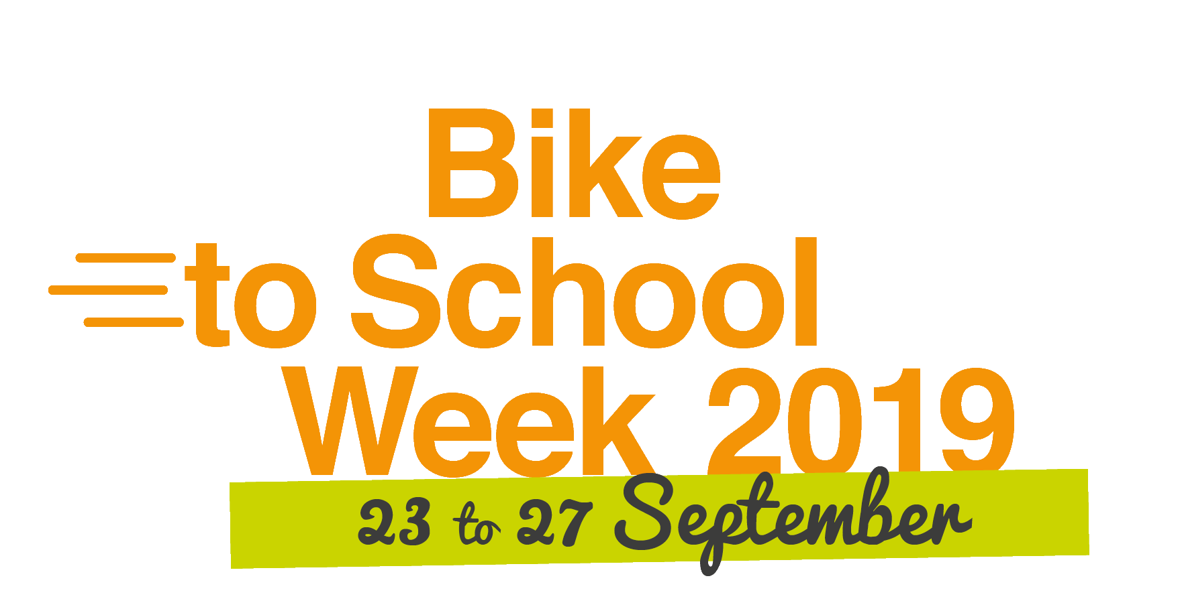

Bike to School Week rolls through the UK
23 – 27 September 2019

Schools across the UK are invited to take part in Bike to School Week

Schools across the UK are being invited to take part in the 2019 Bike to School Week, 23 – 27 September. xxxx (insert organisation name) is inviting schools in xxxx (insert your region – county) to take part.

Organised by Sustrans, the walking and cycling charity, and supported by the Bikeability Trust, Bike to School Week celebrates cycling to school and the benefits of travelling actively for children.

Current figures show that only 2% of primary school children in England currently travel to school by cycle. This is a stark contrast to cycling levels elsewhere such as in the Netherlands, where cycling is the main mode of transport for 49% of primary school children[2]. These figures suggest that more needs to be done in the UK to make cycling an easy, safe, and appealing option for travelling to school.

To support schools in (xxx – insert your region/county) throughout Bike to School Week, there are a range of resources available, including school posters plus a 5-day pack of daily activities to be completed in class and a video guide with simple practices to check your bike is safe to ride. These activities aim to inspire pupils to think about their journeys to school, understand the benefits of active travel, and consider the causes and effects of air pollution.

Outside of the classroom, families are invited to join two competitions:
- The Bike to School Week Sustrans photo competition, where sharing photos of cycling to and from school with the hashtag #SustransWin could see one lucky pupil win a brand new Frog Bike. Parents are also invited to download the Sustrans guide that offers tips on cycling, walking and scooting to school.
- The Bikeability Trust story competition. All entrants of stories about riding to and from school during Bike to School Week will be entered into a prize draw to win a brand new Carrera Abyss 24 inch wheel suitable for 8 – 9 years old: To enter: https://bikeability.org.uk/your-stories/

Xavier Brice, CEO at Sustrans says: “Bike to School Week is a great way to show the benefits of cycling to school for children across the UK, and to promote the positive impact that an active lifestyle can have on children’s wellbeing and overall health.

“We’re calling on schools across the country to take part, use the new resources and inspire children and parents to travel actively to school. We also hope Bike to School Week will send a clear message to the UK government to prioritise a safer and more pleasant environment for children to walk and cycle to school.”

A survey conducted by the Bikeability Trust of over 1,000 parents with children aged 12 and under showed that 63% of parents think cycling is an easy way to increase their child’s physical activity levels[3]. The Bikeability Trust and xxxx (insert organisation) in xxxx (insert your region) will be working throughout Bike to School Week to inspire pupils who have completed their Bikeability training to continue cycling confidently between home and school.

Undertaking professional cycle training can play a huge part in overcoming some of the initial fears of getting out and about on the roads and will equip young riders with the competence and confidence to cycle well and share the road appropriately with other road users. Bikeability training is available (insert section here about what is available in your region and how parents can find out more), and parents can ask their child’s school about what Bikeability training they have planned for the year.

Paul Robison, CEO at the Bikeability Trust says, “Bike to School Week is an excellent chance for children who have done their Bikeability training to put their skills into practice and so develop longer term cycling habits for the future. They can then go on to explore not only the trip to and from school, but also around their neighbourhoods to meet friends, go to the swimming pool, or nip down to the shops.

“We also hope that Bike to School Week will encourage schools to offer more cycle training to children who have not yet had the chance to gain this essential life-skill of being able to cycle competently.”

For more information on Bike to School Week, including access to resources, please visit:
https://www.sustrans.org.uk/campaigns/bike-to-school-week-2019/
https://bikeability.org.uk/bikeability-club/bike-to-school-week/

ENDS

For more information about Bike to School Week in xxxxxx (insert your region), please contact:

Insert your name, email, phone number

Notes to editor:

About Sustrans

Sustrans is the charity making it easier for people to walk and cycle. We are engineers and educators, experts and advocates. We connect people and places, create liveable neighbourhoods, transform the school run and deliver a happier, healthier commute. Sustrans works in partnership, bringing people together to find the right solutions. We make the case for walking and cycling by using robust evidence and showing what can be done. We are grounded in communities and believe that grassroots support combined with political leadership drives real change, fast. Join us on our journey. www.sustrans.org.uk

About Bikeability

Bikeability is the UK government’s cycle education programme, underpinned by the National Standard for cycle training; a set of principles for better and safer cycling. Bikeability is a practical training programme offered at three levels that aims to develop children and young people’s skills and confidence to cycle on roads, and ultimately encourage more people to cycle more safely, more often and is delivered by professional instructors throughout England.
It is funded by the Department for Transport and delivered through local authorities and School Games Organiser Host Schools. In 2017/18 (the last financial year with available programme monitoring data), more than 400,000 DfT-funded Bikeability training places were delivered in just under half of all primary schools in England (outside London, where Bikeability is managed by Transport for London).
For more information about Bikeability visit the Bikeability website https://bikeability.org.uk/ or contact the Bikeability Trust: contact@bikeabilitytrust.org

About xxx (insert your organisation and details below)

Walking and Cycling Statistics, England: 2018, Department for Transport
Contribution to the Transport Planning Research Colloquium, 2008, Santpoort
[3] OurBikesOurAdventure survey, 2019, Bikeability Trust

